Guidelines for Print Posters

- Print posters will be displayed in the Lower Atrium in the Jerry Falwell Library.
- Posters must be printed on foam board (or carefully printed and then attached to foam board). They must be flat and may not be created using tri-fold material. The poster will be disqualified if it is not mounted in one of these ways.
- An easel will be provided for all participants displaying print posters.
- It is good practice to include the following somewhere on the poster:
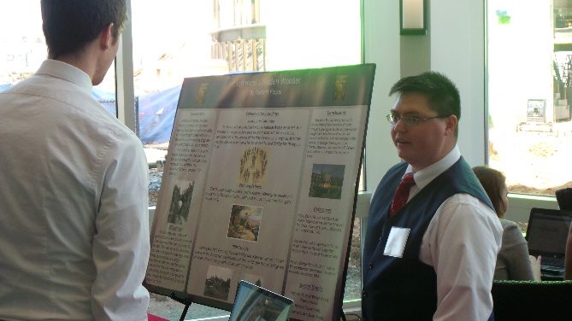
  - Title
  - Project summary and purpose
  - Photographs, drawings, charts, and other visuals
- Avoid using too much unreadable fine print. There should be an understandable “flow” of the poster that the audience can comprehend. You can supplement your poster with your own words or with a handout if you choose.
- Posters must be 3’x4’ and should be displayed in a landscape orientation.
- Posters must utilize the Research Week print poster template.
- Make sure you dress professionally and anticipate any questions that may be asked.
- You are allowed to have co-presenters if you choose to do so. However, they must be included in your submission proposal.
- If you decide to have your poster professionally printed on foam board, we suggest one of these two print shops: FedEx Store in Lynchburg and Signs.com. You can expect that the print on foam board will cost between $70 and $130.
- If you decide to print the poster and attach it to foam board yourself, you can find the appropriately sized foam board here. It is preferable that you print your poster on banner stock. You can attach it to the foam board by pinning it or pasting it.

